**C++ Programming Assignments – L2**

Eight Queen Problem

Eight queens are to be placed on a 8x8 chess board in such a way that no queen checks against any other queen. No two queens should be in the same column or same row or same diagonal. No two queens should be in the adjacent position.

Create a two dimensional array. Presence of queen in a cell should be indicated by putting 1 in the corresponding position in the array. Similarly, absence of queen to be indicated by putting 0 there.

Find out possible outcomes. Display the outcomes as shown below.

**Example of valid positions:**

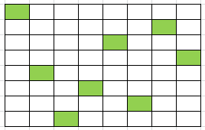

1 0 0 0 0 0 0 0

0 0 0 0 0 0 1 0

0 0 0 0 1 0 0 0

0 0 0 0 0 0 0 1

0 1 0 0 0 0 0 0

0 0 0 1 0 0 0 0

0 0 0 0 0 1 0 0

0 0 1 0 0 0 0 0

**Example of invalid positions:**

